20CS6037
Machine Learning
Anca Ralescu

Decision Tree Learning
We now proceed to see how the entropy and information gains are used to construct decision trees.
First recall that a decision tree is a tree whose nodes correspond to tests:
- For the concept learning problems they correspond to testing values of an attribute and generating subtrees corresponding to each value the tested attribute takes on.

- The leaf nodes of the tree hold the identity of the category corresponding to instances whose descriptions match (are the same as) the branch from the root of the tree to these leaf nodes:
conjunctions of the restrictions on attribute values for each attribute test on the branch.

- The final description for a category is the union (disjunction) of all the branches having identical leaf nodes (all labeled by the same category).

We will consider from this point on the special case of two classes only: + / -
The basic decision tree algorithm:
Given a collection, E, of + / - examples for a concept C, each example described in terms of n attributes, A₁, ..., A_{n}, with k₁, ..., k_{n}, values each, find a decision tree based on E.
1. Start by testing attribute A : first question is HOW DO WE SELECT THE FIRST ATTRIBUTE?
Answer: calculate the information gain corresponding to each attribute and select the attribute with highest information gain.
2. "Project" the example set on the subspace corresponding to the attribute tested at the previous step: this means that we split the example set into subsets, one subset per value of the previous attribute.
3. Construct sub-trees corresponding to each subset, using the remaining attributes, one less attribute than at the previous step. THIS IS A RECURSIVE STEP.
So, what should the stopping rule be?
There are two situations that can occur:
(1) the current set of examples have all the same label (+/-) :
- in this case return the current node with the corresponding label.
(2) there are no more attributes: the current attribute set is empty (all attributes have been used):
- in this case return the current node labeled with the most frequent label in E.
Let us follow this algorithm on the PlayTennis (also in literature referred to as the SaturdayMorning) example.
The original distribution is
P(+ ) = 9/14 ; P(-) = 5/14
and therefore the entropy is H(9/14, 5/14) = 0.940 (textbook equation 3.2)
We now consider each attribute:
1. Humidity : P(Humidity = High) =1/2; P(Humidity = Normal)= 1/2
1.1 Humidity = High
E_{{humidity = high}} = {1,2,3,4,8,12, 14} : P(+) = 3/7, P(-) = 4/7
H_{{humidity = high}} = -(3/7)log2(3/7) - (4/7)log2(4/7) = 0.985
1.2 Humidity = Normal
E_{{humidity = Normal}} = {5,6,7, 9,10,11, 13} : P(+) = 6/7, P(-) = 1/7
H_{{humidity = Normal}} = -(6/7)log2(6/7) - (1/7)log2(1/7) = 0.592
Expected entropy due to humidity:
H_{Humidity} =
P(Humidity = High) H_{{humidity = high}} + P(Humidity = Normal) H_{{humidity = Normal}}
= (1/2) (0.985) + (1/2) (0.592) = 0.7885
Gain(H, H_{Humidity}) = 0.940 - 0.7885 = 0.151
2. Wind: P(Weak) = 8/14; P(Strong) = 6/14
2.1 Wind = Weak
E_{{Wind = Weak}} = { 1-, 3+, 4+, 5+, 8-, 9+, 10+, 13+}
P(+) = 6/8 P(-) = (2/8)
H_{{Wind = Weak}}= -(6/8)log2(6/8) - (2/8)log2(2/8) = 0.8113
2.2 Wind = Strong
E_{{Wind=Strong)} = { 2-, 6-, 7+, 11+, 12+, 14-} : P(+) = P(-) = (3/6) = 1/2
H_{{Wind=Strong}} = 1
Expected entropy due to Wind:
H_{Wind} = P(Wind = Weak)H + P(Wind = Strong ) H =0.8922
Gain (H, H_{Wind}) = 0.940 - 0.8922 = 0.0478
3. Outlook : P(Sunny) = 5/14; P(Rainy) = 5/14; P(Overcast) = 4/14
3.1 {Outlook = Sunny}
E_{{Outlook = Sunny}} = {1-, 2-, 8-, 9+, 11+} P(+) = 2/5; P(-) = 3/5
H_{{Outlook = Sunny}} = -(2/5)log2(2/5) - (3/5)log2(3/5) = 0.9710
3.2 {Outlook = Rainy}
E_{{Outlook = Rainy}} = { 4+,5+,6-,10+, 14-}: P(+) = 3/5, P(-) = 2/5
H_{{Outlook = Rainy}} = -(2/5)log2(2/5) - (3/5)log2(3/5) = 0.9710
3.3 {Outlook = Overcast}
E_{{Outlook = Overcast}} = {3+, 7+, 12+, 13+} P(+) = 1; P(-) = 0
H_{{Outlook = Overcast}}= 0
Expected entropy due to Outlook
H_{Outlook} = 2 (0.9710)(5/14) = 0.6935
Gain(H, H_{Outlook}) = 0.940 - 0.6935 = 0.2465
4. Temperature: P(Hot) = 4/14; P(Mild) = 6/14 ; P(Cool) = 4/14
4.1 {Temperature = Hot}
E_{{Temperature = Hot}} = { 1-, 2-, 3+, 13+} P(+) = 2/4; P(-) = 2/4
H_{{Temperature = Hot}} = 1
4.2 {Temperature = Mild}
E_{{Temperature = Mild}} = { 4+, 8-, 10+, 11+, 12+, 14-}: P(+) = 4/6; P(-) = 2/6
H_{{Temperature = Mild}} = -(4/6)log2(4/6) - (2/6)log2(4/6) = 0.9183
4.3 {Temperature = Cool}
E_{{Temperature = Cool}} = { 5+, 6-, 7+, 9+}: P(+) = 3/4; P(-) = 1/4
H_{{Temperature = Cool}} = - (3/4)log2(3/4) - (1/4)log2(1/4) = 0.8113
Expected entropy due to Temperature
H_{Temperature} = (4/14)(1) + (6/14)(0.9183) + (4/14)(0.8113) = 0.9111
Gain(H, H_{Temperature} = 0.940 - 0.9111 = 0.0289
Thus we have the following:
Attribute | Gain
Outlook | 0.2465 (largest)
Temperature | 0.0289
Humidity | 0.151
Wind | 0.0478
Therefore Outlook is selected as the next (here the first) testing attribute.
Since outlook has highest information gain it becomes the root of the tree.
Now,
E _{Outlook = overcast} = { 3+, 7+, 12+, 13+}
that is all examples are positive and therefore we do not expand the tree here and label the node by +
Next we consider Outlook = Sunny
E _{{Outlook = Sunny}} = { 1-, 2-, 8-, 9+, 11+}
We already know
H_{{Outlook = Sunny}} = -(2/5)log2(2/5) - (3/5)log2(3/5) = 0.9710
Consider now the remaining attributes:
- Temperature: takes values in { Hot, Mild, Cool}
E {Outlook = Sunny, Temperature = Hot} = {1-, 2-}; H {Outlook = Sunny, Temperature = Hot}= 0
E {Outlook = Sunny, Temperature = Mild } = {8-, 11+}; H {Outlook = Sunny, Temperature = Mild }= 1
E {Outlook = Sunny, Temperature = Cool } = {9+}; H {Outlook = Sunny, Temperature = Cool}= 0
Expected entropy:
P(Temperature = Hot | Outlook = Sunny) = 2/5
P(Temperature = Mild | Outlook = Sunny) = 2/5
P(Temperature = Cool | Outlook = Sunny) = 1/5
EH {Temperature | Outlook = Sunny} = (2/5)(0) + (2/5)(1) + 91/5)(0) = 2/5

IG(Temperature; O) = 0.9710- 0.4 = 0.571
Similarly,
EH _{{Humidity | Outlook = Sunny}}= 0
IG(Humidity; O) = 0.9710
Since this is the maximum information gain we can stop evaluating here.
Therefore the next node in the tree on the branch {Outlook = Sunny} should test Humidity.
Since
E {Outlook = Sunny, Humidity = High} = {1-, 2-, 8-} and
E{Outlook = Sunny, Humidity = Normal} = { 11+, 9+}
there is no further expansion on this branch after this test.
Now we go back to the branch {Outlook = Rain}
E{Outlook = Rainy, Humidity = High} = {4+, 14+}; H{Outlook = Rainy, Humidity = High} = 0
E{Outlook = Rainy, Humidity = Normal}= {5+, 6-, 10+}; H{Outlook = Rainy, Humidity = Normal} = 0.9183

P(Humidity = High | Outlook = Rainy) = 2/5; P(Humidity = Normal | Outlook = Rainy) = 3/5
and therefore
E_{{Humidity | Outlook = Rainy}} H = (3/5)0.9183 = 0.5510
IG(Outlook=Rain; H) = 0.9710 - 0.5510 = 0.42
Similarly, for Temperature we obtain
E{Outlook = Rainy, Temperature = Hot} = { }: add a leaf with the most common label in the training example: +
E{Outlook = Rainy, Temperature = Mild}= { 4+, 10+, 14-}; H{Outlook = Rainy, Temperature = Mild} = 0.9183
E{Outlook = Rainy, Temperature = Cool}= {5+, 6-; H{Outlook = Rainy, Temperature = Cool} = 1

P(Temperature = Mild | Outlook = Rainy) = 3/5 ; P(Temperature = Cool | Outlook = rainy) = 2/5
and therefore
E{Temperature | Outlook = Rainy} H = (3/5)0.9183 = 0.5510
IG(Outlook=Rain; T) = 0.9710 - 0.5510 = 0.42

For Wind
E{Outlook = Rainy, Wind = Strong}= { 6-, 14-}; H{Outlook = Rainy, Wind = Strong} = 0
E_{{Outlook = Rainy, Wind = Weak}}= {4+, 5+, 10+, } H_{{Outlook = Rainy, Wind=Weak}} = 0
E_{{Wind| Outlook = Rainy}} H = 0
IG(Outlook = Rain; Wind) = 0.9710
This is the maximum so the next test along this branch is on the attribute Wind.
For each value of the attribute Wind the example set is split into only:
- positive examples, when the wind is weak and
- negative examples, when wind is strong
Therefore, the tree is finished. We have the final tree as follows:
Outlook
|
------------------------------------------------------------
| | |
Overcast Sunny Rain
| | |
+ Humidity Wind
| |
------------------- ----------
| | | |
High Normal Strong Weak
| | | |
- + - +

In linear format the tree is:
Outlook
Overcast: +
Sunny
Humidity
High: -
Normal: +
Rain
Wind
Strong: -
Weak: +
Description of the result: collect + branches and make rules: use AND along a branch OR between branches.
If (Outlook is overcast) then PlayTennis
OR
If (Outlook is Sunny) AND (Humidity is Normal) then PlayTennis
OR
If (Outlook is rain) AND (Wind is Weak) then PlayTennis

ISSUES IN LEARNING DECISION TREES
Overfitting:
- hypothesis that performs "too well" on the training example set;
- not "well enough" on the test set.
For example: suppose we add another example: (Sunny, Hot, Normal, Strong, -)
In the previous tree it comes under the branch
Outlook
Overcast : +
Sunny
Humidity
High: -
Normal: + but here the tree outputs + and the new example is -
so a new branch testing temperature or wind will be created
Rain
Wind
Strong: -
Weak: +
In general, the more attributes are used the more there is a danger for overfitting
Q: How to eliminate overfitting?
A: Keep tree short
- Stop the tree (when? Hard to know: will look at this later (Chapter 5?)
- Overfit and then eliminate some tests (rule post prunning).

To do this we just drop some of the conditions in the rules obtained. We need to test the effect. Introduce another example set: the validation set: 2/3 of the training set is for training proper (for constructing the tree - eventually overfilling the data) 1/3 is for validation purposes. Drop successively conditions and see the effect on the validation set. A condition can be dropped if the performance of the resulting rule on the validation set is as at least as good as the previous (un-pruned rule).
Example: Obtain a decision tree for the expression A v (B ^ C)
example | A | B | C | B ^ C | A v (B ^ C) | Class
1 | T | T | T | T | T | T +
2 | T | T | F | F | T | T +
3 | T | F | T | F | T | T +
4 | T | F | F | F | T | T +
5 | F | T | T | T | T | T +
6 | F | T | F | F | F | F -
7 | F | F | T | F | F | F -
8 | F | F | F | F | F | F -

"Empirical" decision tree:
Each line corresponding to T+ is a branch in the tree;
Use conjunction along the branch;
Use disjunction among branches.
Thus, the concept holds if: (A ^ B ^ C) v (A ^ B ^ ~C) v (A ^ ~B ^ C) v (A ^ ~B ^ ~C) v (~A ^ B ^ C)
^: and
v: or
~: not
Total number of examples: 8
H = -(5/8)log(5/8) - (3/8)log(3/8) = 0.9544

Attribute A
A= T: E_{{A=T}} = {1+,2+,3+,4+} H_{{A=T}} = 0
A= F: E_{{A=F}} = {5+, 6-, 7-, 8-} H_{{A=F}} = -(1/4)log(1/4) - (3/4)log2(3/4) = 0.8113
P(A=T) = P(A=F) = 1/2
E_{A}H = 0.8113(1/2) = 0.4056
IG(A) = 0.9544 - 0.4056 = 0.5488
Attribute B
B= T : E_{{B=T}} = {1+, 2+5+, 6-}; H_{{B=T}} = -(1/4)log(1/4) - (3/4)log2(3/4) = 0.8113
B=F : E_{{B=F}} = {3+, 4+, 7-, 8-} ; H_{{B=F}} = 1
E_{B}H = (0.8113)(1/2) + (1/2) = 0.9056
IG(B) = 0.9544 - 0.9056
Attribute C : exactly like B :
E_{C}H = (0.8113)(1/2) + (1/2) = 0.9056
IG(C) = IG(B)
Highest information gain: A
A
T: +
F
B : T
C: T : +
F : -
F : -
Extract a rule from this tree: Concept if (A) v (~A ^ B ^ C)
Truth table
A | ~A | B | C | B ^ C | ~A ^ B ^ C | (A) v (~A ^ B ^ C) | A v (B ^ C)
T | F | T | T | T | F | T | T
T | F | T | F | F | F | T | T
T | F | F | T | F | F | T | T
T | F | F | F | F | F | T | T
F | T | T | T | T | T | T | T
F | T | T | F | F | F | F | F
F | T | F | T | F | F | F | F
F | T | F | F | F | F | F | F
Continuous valued attribute: discretize
- arrange the examples ordered by the values of the attribute in question
- replace a range for the attribute value by an inequality:
  - Attribute value < c where c is the value in the range where the label changes from = to - or from - to +.
Missing attribute values:
- fill in: for example, use the average of the existing values for that attribute for that class
- use probability distribution

Other measures for selecting attributes:
- Cost
- Split information: $SplitInformation \left(S, A\right)= - \sum_{i=1}^{c}{\frac{|S_{i|}}{|S|}} \log_{2} \frac{|S_{i|}}{|S|}$
- Gain Ratio: $GainRatio= \frac{Gain(S, A)}{SplitInformation(S, A)}$

Q: What is H, the hypothesis space in ID3?
Answer: The hypothesis space in ID3 is collection of all possible decision trees generated in the order
“simple complex” based on the evaluation function provided by the information gain.
The hypothesis space is COMPLETE: it always contains the concept (given the attributes).
The hypothesis space is generated one tree at a time - this means that only one instance (one tree) is maintained.
Some drawbacks:
- Cannot tell how many other trees are consistent with the data.
- No backtracking: local optimum solution
- Non incremental: at each step ID3 uses all the examples to extract statistical quantities (information gain) on which it bases its decisions.
  - good: less sensitive to individual examples; ability to use noisy data; incomplete data.
  - bad: impossible to add "new" examples.
The inductive bias of ID3 follows from its search strategy and reflects interaction between the information gain and training examples:
- favor shorter trees over longer ones
- attributes with higher information gain are nearer to the root (root has highest information gain)

For VS_CE the inductive bias follows from the search space.
algorithm | search space | search strategy | inductive bias
VS_CE | incomplete (only conjunctive hypotheses): target concept is not guaranteed to be there | complete: finds every hypothesis consistent with the example set | restriction bias: follows from the structure of the hypothesis space
ID3 | complete (disjunctions of conjunctions) : target concept guaranteed to be there | incomplete: only one hypothesis is maintained. | preference bias: follows form the search strategy.
Combining the restriction and preference bias:
- the form of the target functions: linear versus nonlinear - preference bias;
- method of fitting the selected function (determining coefficients): restriction bias (LMS).
EXTENSIONS OF ID3
INCREMENTAL INDUCTION OF DECISION TREES (Utgoff, 1989)
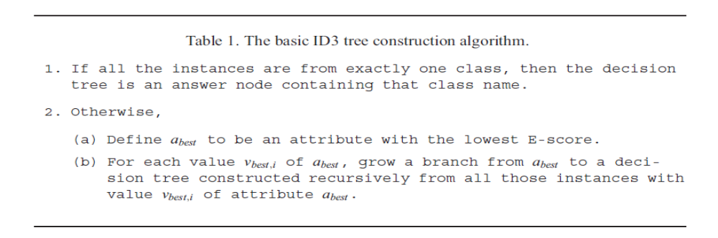
E-score (needed to compute the Information Gain, IG)
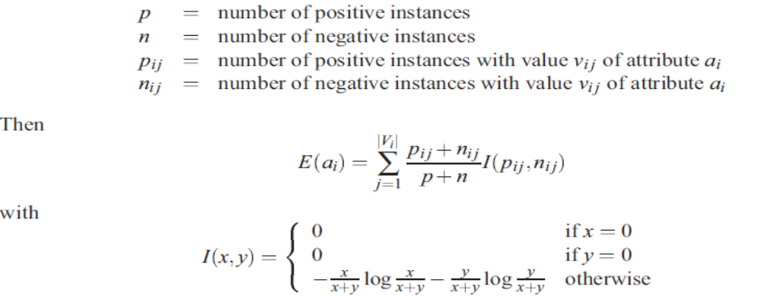

ID4 algorithm
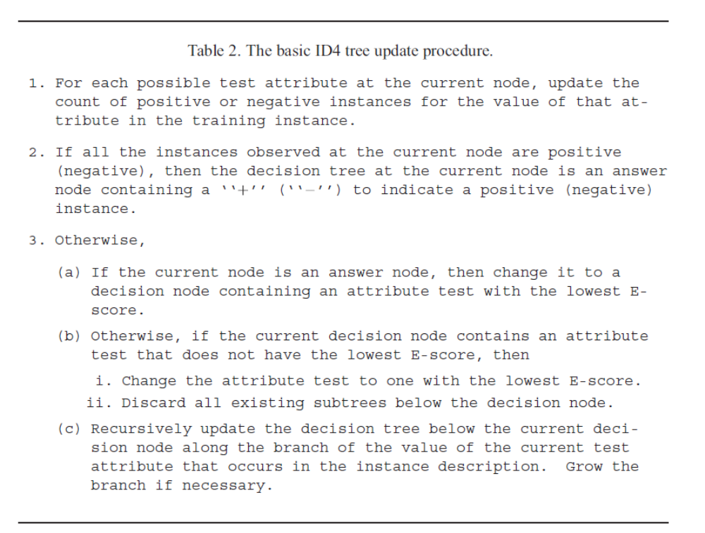
ID4 includes χ² test for independence: to eliminate attributes which are dependent, to avoid overfitting.
Problems with stability…

ID5
